Kevin Geraghty, Chairman  Michael Chizy, Vice Chairman  Ryan Fattman, Clerk  John L. Hebert  Michael Frustaci  James A. Smith, Town Administrator | 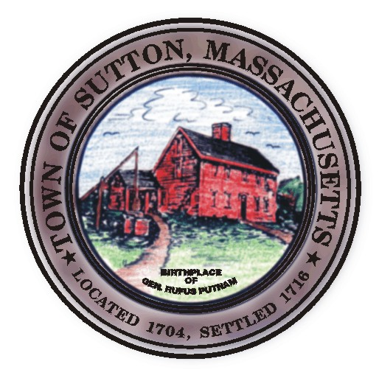 | Sutton Town Hall  4 Uxbridge Road  Sutton, Massachusetts 01590  (508) 865-8727  Fax: (508) 865-8721
Town Of Sutton
Board Of Selectmen

Meeting Agenda

7:00 p.m. – Tuesday, April 8, 2008

Sutton Town Hall, Selectmen’s Meeting Room

- Call to Order, Pledge of Allegiance at 7:00 p.m.

- Public Forum: Limited to 5 minutes per topic. Discussion or comments about town employees or agency members shall be avoided so as not to violate individual’s rights.

- Minutes
  - Board of Selectman minutes from 03/25/08

- Sponsored Agenda and Action Items

2. Ratify appointments of Ken Malo onto the Board of Health and Leo Lavin onto the Sutton Community
Television board (SCTV)
3. William Fredericks, 96 Wheelock Road, interested in a position on the Board of Health

* PUBLIC HEARING *

4. Angelo Bifano & Richard Cole dba B&C Automotive and Sales, Inc. request a Class II
license at 32 Boston Road (Chases Garage) for automotive repair & used car sales.
End of Public Hearing

- Edward H. Kooyomjian Jr. re: Blue Jay restaurant and continuing maintenance of signage & landscaping within
Right of Way on 2 means of access onto Central Turnpike and Putnam Hill Road.

- Presentation of Warrant

- Presentation of Verizon Issuing Authority Report (IAR)

- Building Department fee schedule

- Town Administrator Update
- Announcements
- Selectman’s Roundtable: Correspondence and Business Topics
- Executive Session
Adjournment

